1. Knowing the circuit from figure 1 as being with a three phase direct symmetrically system of voltage u10, u20, u30, with V and $R=ωL=\frac{1}{ωC}=10 Ω$, $r=\frac{10}{\sqrt{3}} Ω$ determine the instantaneous values of the currents, the phasor‘s diagram and verify the results with power balance.

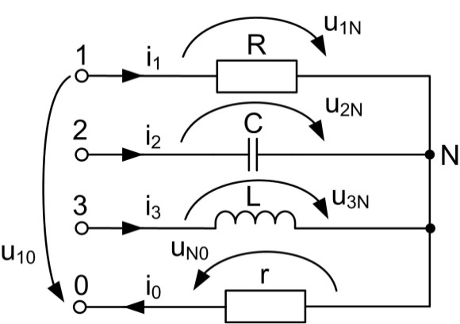

Fig. 1a

${\underline{Z}}_{1}=R=10;$ ${\underline{Z}}_{2}=\frac{1}{jωC}=-10j;$ ${\underline{Z}}_{3}=jωL=10j .$

The consumer is an unbalanced one and we have to compute the voltage drop on the neutral conductor with Millman’s theorem:

:

$${\underline{Y}}_{1}=\frac{1}{{\underline{Z}}_{1}}=\frac{1}{10}; {\underline{Y}}_{2}=\frac{1}{{\underline{Z}}_{2}}=\frac{j}{10}; {\underline{Y}}_{3}=\frac{1}{{\underline{Z}}_{3}}=-\frac{j}{10}; {\underline{Y}}_{0}=\frac{1}{{\underline{Z}}_{0}}=\frac{\sqrt{3}}{10}.$$

The complex values of the voltage direct symmetrically supply system is:

${\underline{U}}_{10}=U_{10}e^{j0}=100;$ $${\underline{U}}_{20}={\underline{U}}_{10}e^{-j\frac{2π}{3}}=100 (-\frac{1}{2}-j\frac{\sqrt{3}}{2}) ;$$

$${\underline{U}}_{30}={\underline{U}}_{10}e^{-j\frac{4π}{3}}={\underline{U}}_{10}e^{j\frac{2π}{3}}=100 (-\frac{1}{2}+j\frac{\sqrt{3}}{2}) .$$

By introducing all the values in the Millmann ‘s formula is obtained ${\underline{U}}_{N0}=100.$

The currents will be computed by diminishing the applied voltage on each phase with the voltage drop on the neutral conductor:

$${\underline{I}}_{1}=\frac{{\underline{U}}_{10}-{\underline{U}}_{N0}}{{\underline{Z}}_{1}}={\underline{Y}}_{1} \left({\underline{U}}_{10}-{\underline{U}}_{N0}\right)=\frac{1}{10} \left(100-100\right)=0$$

$${\underline{I}}_{2}=\frac{{\underline{U}}_{20}-{\underline{U}}_{N0}}{{\underline{Z}}_{2}}={\underline{Y}}_{2} \left({\underline{U}}_{20}-{\underline{U}}_{N0}\right)=\frac{1}{10}[100 \left(-\frac{1}{2}-j\frac{\sqrt{3}}{2}\right)-100]=10j\left(-\frac{1}{2}-j\frac{\sqrt{3}}{2}\right)-10j=5\sqrt{3}-15j$$

$${\underline{I}}_{3}=\frac{{\underline{U}}_{30}-{\underline{U}}_{N0}}{{\underline{Z}}_{3}}={\underline{Y}}_{3} \left({\underline{U}}_{30}-{\underline{U}}_{N0}\right)=-\frac{j}{10} \left[100 \left(-\frac{1}{2}+j\frac{\sqrt{3}}{2}\right)-100\right]==-10j\left(-\frac{1}{2}+j\frac{\sqrt{3}}{2}\right)+10j=5\sqrt{3}+15j$$

$${\underline{I}}_{0}={\underline{I}}_{1}+{\underline{I}}_{2}+{\underline{I}}_{3}=\frac{{\underline{U}}_{N0}}{{\underline{Z}}_{0}}= {\underline{Y}}_{0}{\underline{U}}_{N0}=\frac{\sqrt{3}}{10}∙100=10\sqrt{3}$$

The phasor’s diagram is in the figure 1b.

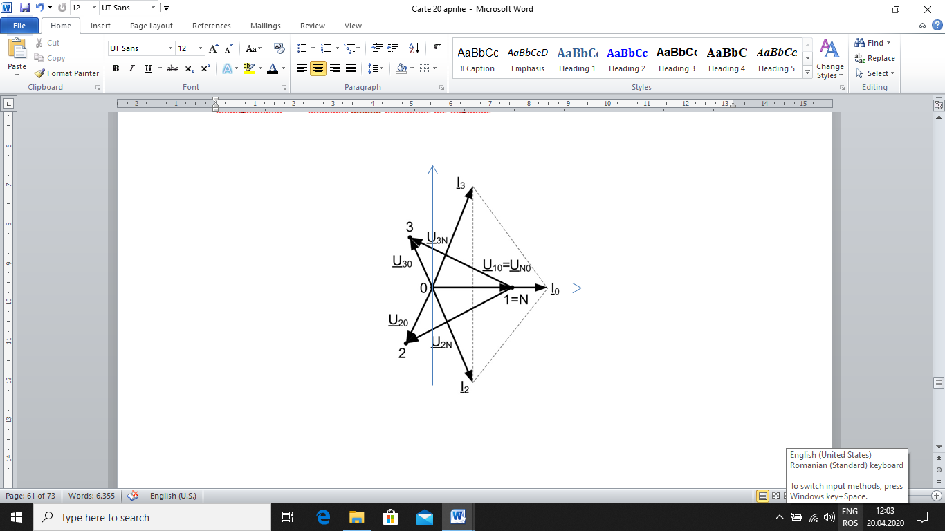

Fig.1b.

We transform then the complex values of the currents into instantaneous values:

$$i_{1}=0$$

$$i_{2}=I_{2}\sqrt{2}\sin\left(ωt+α_{2}\right)=\sqrt{2}\left|{\underline{I}}_{2}\right|\sin\left(ωt+α_{2}\right)=10\sqrt{3}\sqrt{2}\sin{(ωt}-\frac{π}{3})=10\sqrt{6}{\sin{(ωt}}-\frac{π}{3}).$$

$${ r}_{2}={ I}_{2}=\left|{\underline{I}}_{2}\right|=\sqrt{a_{2}^{2}+b_{2}^{2}}=\sqrt{({5\sqrt{3})}_{}^{2}+{15}^{2}+}=5\sqrt{3+3^{2}}=5\sqrt{12}=10\sqrt{3}$$

$$\left\{\begin{aligned}cosα_{2}=\frac{1}{2}; \\ sinα_{2}=\frac{15}{10\sqrt{3}}=-\frac{\sqrt{3}}{2} . \end{aligned}→{ α}_{2}=-\frac{π}{3}.\right.$$

$$i_{3}=I_{3}\sqrt{2}\sin\left(ωt+α_{3}\right)=\sqrt{2}\left|{\underline{I}}_{3}\right|\sin\left(ωt+α_{3}\right)=10\sqrt{3}\sqrt{2}\sin{(ωt}+\frac{π}{3})=10\sqrt{6}{\sin{(ωt}}+\frac{π}{3}).$$

$${ r}_{3}={ I}_{3}=\left|{\underline{I}}_{3}\right|=\sqrt{a_{3}^{2}+b_{3}^{2}}=\sqrt{({5\sqrt{3})}_{}^{2}+{15}^{2}+}=5\sqrt{3+3^{2}}=5\sqrt{12}=10\sqrt{3}$$

$$\left\{\begin{aligned}cosα_{3}=\frac{1}{2}; \\ sinα_{3}=\frac{15}{10\sqrt{3}}=\frac{\sqrt{3}}{2} .\end{aligned} →{ α}_{2}=\frac{π}{3}.\right.$$

$$i_{0}=I_{0}\sqrt{2}\sin\left(ωt+α_{0}\right)=10\sqrt{6}{\sin{ωt}}.$$

Power balance

Because the load is unbalanced, we compute the apparent complex power supplied in the circuit by the supply system as a sum of the apparent complex power on each phase:

$${\underline{S}}_{G}= {\underline{U}}_{10}∙{\underline{I}}_{1}^{*}+{ \underline{U}}_{20}∙{\underline{I}}_{2}^{*}+{ \underline{U}}_{30}∙{\underline{I}}_{3}^{*}=100∙0+100\left(-\frac{1}{2}-j\frac{\sqrt{3}}{2}\right)\left(5\sqrt{3}+15j\right)+100 \left(-\frac{1}{2}+j\frac{\sqrt{3}}{2}\right)\left(5\sqrt{3}-15j\right)=1000\sqrt{3}=P_{G}+jQ_{G}$$

$$P_{G}=1000\sqrt{3}W; { Q}_{G}=0 VAr.$$

The absorbed active power and the absorbed reactive power will be:

2. Knowing that the circuit is supplied by a symmetrical system of u10, u20, u30, and V.

determine the currents, the phasor’s diagram and verify the results with power balance in two situations: a closed, a opened.

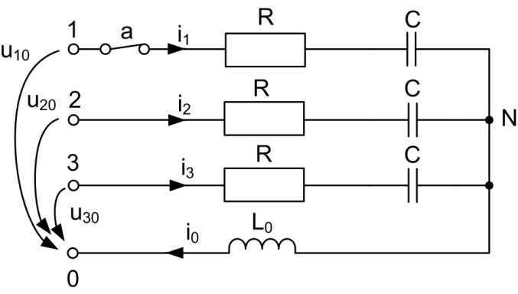

Fig. 2a

a. *a* closed

$${\underline{\text{Z}}}_{\text{1}}={\underline{\text{Z}}}_{\text{2}}={\underline{\text{Z}}}_{\text{3}}=R+\frac{1}{jωC}\text{=10}\text{(1}-\text{j}\text{)}$$

$${\underline{\text{U}}}_{\text{10}}={\text{U}}_{\text{10}}e^{j0}=200;$$

$${\underline{\text{U}}}_{\text{20}}= {\underline{\text{U}}}_{\text{10}}e^{-j\frac{2π}{3}}=200 (-\frac{1}{2}-j\frac{\sqrt{3}}{2}) ;$$

$${\underline{\text{U}}}_{\text{30}}= {\underline{\text{U}}}_{\text{10}}e^{-j\frac{4π}{3}}={\underline{\text{U}}}_{\text{10}}e^{j\frac{2π}{3}}=200 (-\frac{1}{2}+j\frac{\sqrt{3}}{2}) .$$

$${\underline{\text{I}}}_{\text{1}}\text{=}\frac{{\underline{\text{U}}}_{\text{10}}}{{\underline{\text{Z}}}_{\text{1}}}=\frac{200}{\text{10(1-j)}}=\frac{20\text{(1+j)} }{\text{(1+j)(1-j)} }=1\text{0(1+j)}$$

The instantaneous value is:

$${\text{ r}}_{\text{1}}\text{=}{\text{ I}}_{\text{1}}\text{=}\left|{\underline{\text{I}}}_{\text{1}}\right|=\sqrt{{\text{a}}_{\text{1}}^{\text{2}}\text{+}{\text{b}}_{\text{1}}^{\text{2}}}\text{=}\sqrt{{10}^{2}+{10}^{2}}\text{=}\text{10}\sqrt{\text{2}}$$

$$\left\{\begin{aligned}\text{co}\text{s}α_{1}\text{=}\frac{\sqrt{\text{2}}}{2}\text{;} \\ \text{sin}α_{1}\text{=}\frac{\sqrt{\text{2}}}{2}\text{ . }\end{aligned}\text{→}{ α}_{1}\text{=}\frac{\text{π}}{\text{4}}\text{.}\right.$$

$${\text{i}}_{\text{1}}\text{=}\sqrt{\text{2}}\left|{\underline{\text{I}}}_{\text{1}}\right|\text{sin}\left(\text{ω}\text{t+}α_{1}\right)\text{=10}\sqrt{\text{2}}∙\sqrt{\text{2}}\text{sin}{\text{(}\text{ω}\text{t}}+\frac{\text{π}}{\text{4}}\text{)}\text{=}\text{20}\text{sin}{\text{(}\text{ω}\text{t}}+\frac{\text{π}}{\text{4}}\text{)}$$

The other currents from the symmetrical system of currents will be:

i0=0.

The phasor’s diagram for voltages and currents is represented in figure 2b.

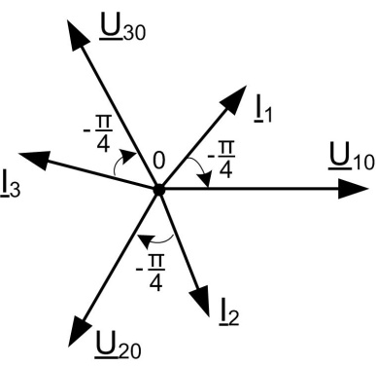

Fig. 2b.

Power balance

$${\underline{\text{S}}}_{\text{G}}\text{= }{ 3 \underline{\text{U}}}_{\text{10}}\text{∙}{\underline{\text{I}}}_{\text{1}}^{\text{*}}=3∙\text{200}∙10\left(1-j\right)=\text{6000}-\text{6000}j={\text{P}}_{\text{G}}+j{\text{Q}}_{\text{G}}$$

$${\text{P}}_{\text{G}}\text{=6000W;} {\text{Q}}_{\text{G}}\text{=} -\text{6000VAr.}$$

$${\text{P}}_{\text{Z}}\text{=3 R}∙I_{\text{1}}^{\text{ 2}}\text{=3 }\text{∙}\text{10}\text{∙}{\text{(}\text{10}\sqrt{\text{2}}\text{)}}^{2} \text{=}\text{6000 W.}$$

$${\text{Q}}_{\text{Z}}\text{=}-\text{3}\text{∙}\frac{1}{ωC}\text{∙}I_{\text{1}}^{\text{ 2}}\text{=}-\text{3 }\text{∙}\text{10}\text{∙}{\text{(}\text{10}\sqrt{\text{2}}\text{)}}^{2} \text{= }-\text{6000 VAr}.$$

b. *a* opened

$${\underline{\text{Z}}}_{\text{1}}=∞{ \underline{\text{Z}}}_{\text{2}}={\underline{\text{Z}}}_{\text{3}}=R+\frac{1}{jωC}\text{=10}\text{(1}-\text{j}\text{)}$$

$${\underline{\text{Z}}}_{\text{0}}\text{=}j\text{ω}L_{0}=5j$$

$${\underline{\text{Y}}}_{\text{1}}\text{=}\frac{1}{{\underline{\text{Z}}}_{\text{1}}}=\frac{1}{∞}=0 {\underline{\text{Y}}}_{\text{2}}\text{=}{\underline{\text{Y}}}_{\text{3}}\text{=}\frac{1}{{\underline{\text{Z}}}_{\text{2}}}=\frac{1}{\text{10}\text{(1}-\text{j}\text{)}} {\underline{\text{Y}}}_{\text{0}}\text{=}\frac{1}{{\underline{\text{Z}}}_{\text{0}}}=\frac{1}{5j}$$

The voltage drop on the neutral conductor with Millman’s theorem:

$${\underline{\text{U}}}_{\text{N0}}\text{=}\frac{{\underline{\text{Y}}}_{\text{1}} {\underline{\text{U}}}_{\text{10}}+{\underline{\text{Y}}}_{\text{2}} {\underline{\text{U}}}_{\text{20}}+{\underline{\text{Y}}}_{\text{3}} {\underline{\text{U}}}_{\text{30}}}{{\underline{\text{Y}}}_{\text{1}}+{\underline{\text{Y}}}_{\text{2}}+{\underline{\text{Y}}}_{\text{3}}+{\underline{\text{Y}}}_{\text{0}}}=-\text{10}\text{0}j$$

The phase currents:

$${\underline{\text{I}}}_{\text{1}}\text{=}\frac{{\underline{\text{U}}}_{\text{10}}-{\underline{\text{U}}}_{\text{N0}}}{{\underline{\text{Z}}}_{\text{1}}}={\underline{\text{Y}}}_{\text{1}} \left({\underline{\text{U}}}_{\text{10}}-{\underline{\text{U}}}_{\text{N0}}\right)=0$$

$${\underline{\text{I}}}_{\text{2}}\text{=}\frac{{\underline{\text{U}}}_{\text{20}}-{\underline{\text{U}}}_{\text{N0}}}{{\underline{\text{Z}}}_{\text{2}}}={\underline{\text{Y}}}_{\text{2}} \left({\underline{\text{U}}}_{\text{20}}-{\underline{\text{U}}}_{\text{N0}}\right)=\frac{1}{\text{10}\text{(1}-\text{j}\text{)}}\left[200 \left(-\frac{1}{2}-j\frac{\sqrt{3}}{2}\right)+\text{10}\text{0}j\right]=\frac{\text{(1+}\text{j}\text{)}}{\text{10}\text{(1+}\text{j}\text{)(1}-\text{j}\text{)}}\left(-100-100\sqrt{3}j+\text{10}\text{0}j\right)=\frac{\text{100(1+}\text{j}\text{)}}{\text{10}\text{(1+}\text{j}\text{)(1}-\text{j}\text{)}}\left(-1-j\sqrt{3}+j\right)=5\text{(1+}\text{j}\text{)}\left(-1-j\sqrt{3}+j\right)=5(-2+\sqrt{3}-\sqrt{3}j)$$

$${\underline{\text{I}}}_{\text{3}}\text{=}\frac{{\underline{\text{U}}}_{\text{30}}-{\underline{\text{U}}}_{\text{N0}}}{{\underline{\text{Z}}}_{\text{3}}}={\underline{\text{Y}}}_{\text{3}} \left({\underline{\text{U}}}_{\text{30}}-{\underline{\text{U}}}_{\text{N0}}\right)=\frac{1}{\text{10}\text{(1}-\text{j}\text{)}}\left[200 \left(-\frac{1}{2}+j\frac{\sqrt{3}}{2}\right)+\text{10}\text{0}j\right]==\frac{\text{(1+}\text{j}\text{)}}{\text{10}\text{(1+}\text{j}\text{)(1}-\text{j}\text{)}}\left(-100+100\sqrt{3}j+\text{10}\text{0}j\right)=\frac{\text{100(1+}\text{j}\text{)}}{\text{10}\text{(1+}\text{j}\text{)(1}-\text{j}\text{)}}\left(-1+j\sqrt{3}+j\right)=5\text{(1+}\text{j}\text{)}\left(-1+j\sqrt{3}+j\right)=5(-2-\sqrt{3}+\sqrt{3}j)$$

$${\underline{\text{I}}}_{\text{0}}=\frac{{\underline{\text{U}}}_{\text{N0}}}{{\underline{\text{Z}}}_{\text{0}}}= {\underline{\text{Y}}}_{\text{0}}{\underline{\text{U}}}_{\text{N0}}=\frac{1}{5j}∙(-\text{10}\text{0}j)=-20$$

*Verification*

$${\underline{\text{I}}}_{\text{0}}={\underline{\text{I}}}_{\text{1}}+{\underline{\text{I}}}_{\text{2}}+{\underline{\text{I}}}_{\text{3}}=0+\text{5}\left(-2+\sqrt{3}-\sqrt{3}j\right)+\text{5}\left(-2-\sqrt{3}+\sqrt{3}j\right)=-20$$

Phasor’s diagram for case b is represented in figure 2c.

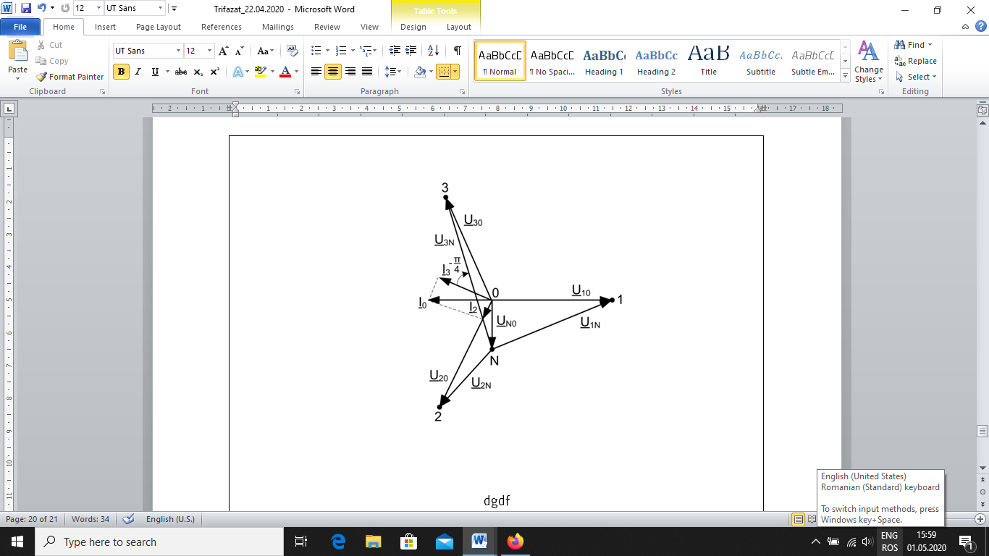

Fig. 2c

Power balance

$${\underline{\text{S}}}_{\text{G}}\text{= }{ \underline{\text{U}}}_{\text{10}}\text{∙}{\underline{\text{I}}}_{\text{1}}^{\text{*}}\text{+}{ \underline{\text{U}}}_{\text{20}}\text{∙}{\underline{\text{I}}}_{\text{2}}^{\text{*}}\text{+}{ \underline{\text{U}}}_{\text{30}}\text{∙}{\underline{\text{I}}}_{\text{3}}^{\text{*}}\text{=200}\text{∙}0+\text{200}\left(-\frac{1}{\text{2}}-j\frac{\sqrt{\text{3}}}{\text{2}}\right)\left[\text{5}\left(-\text{2}+\sqrt{\text{3}}-\sqrt{\text{3}}j\right)\right]+$$

$$\text{200} \left(-\frac{1}{\text{2}}+j\frac{\sqrt{\text{3}}}{\text{2}}\right)\left[\text{5}(-\text{2}-\sqrt{\text{3}}+\sqrt{\text{3}}j)\right]={\text{500}\left(10-6j\right)=\text{5000}-\text{300}0j= P}_{G}+jQ_{G}$$

$${\text{P}}_{\text{G}}\text{=5000W; }{\text{Q}}_{\text{G}}\text{=}-\text{300}0\text{ VAr.}$$

${\text{P}}_{\text{Z}}\text{=R}∙I_{1}^{2}\text{+R}∙I_{2}^{2}\text{+R}∙I_{3}^{2}\text{=}\text{10}\text{∙}\text{0+10}\text{∙}\left[{5\left(-2+\sqrt{3}\right)}^{2}+{5\left(\sqrt{3}\right)}^{2}\right]+10∙\left[{5\left(-2-\sqrt{3}\right)}^{2}+{5\left(\sqrt{3}\right)}^{2}\right]=250\left(4+4\sqrt{3}+3+3\right)+250\left(4-4\sqrt{3}+3+3\right)=\text{2500 +2500=5000W}$.

$${\text{Q}}_{\text{Z}}\text{=}-\frac{1}{ωC}\text{∙}I_{1 }^{2}-\frac{1}{ωC}\text{∙}I_{2 }^{2}-\frac{1}{ωC}\text{∙}I_{3 }^{2}\text{+}\text{ω}L_{0}I_{0}^{2}=-10∙0-10∙I_{2 }^{2}-10∙I_{3 }^{2}+5{∙I}_{0 }^{2}=10\left[{5\left(-2+\sqrt{3}\right)}^{2}+{5\left(\sqrt{3}\right)}^{2}\right]+10 \left[{5\left(-2-\sqrt{3}\right)}^{2}+{5\left(\sqrt{3}\right)}^{2}\right]\text{-5}\text{∙}{20}^{2}\text{=}-\text{5000+2000=}-\text{3000}\text{VAr}$$